Quiz-2

Answer ALL the questions Total marks - **20**

## Name (Family name first in capital letters): GOH Wei Zhe

**Signature:** 

## Submission date: 5/10/2022

**Important points:**

* Make suitable assumptions if any data is missing in the question.
* Always *round off the answers to the nearest integers* whenever necessary. For example, 23.4 is 23, 23.5 is 24, and 23.7 is 24.
* Take the printout of this answer script, write your answers clearly, only within the answer boxes/tables/blanks provided. Finally, scan and submit your answer script in Moodle. Vague answers will receive zero marks.

1. What is a Laplacian filter? What are the steps to sharpen the image using Laplacian method?

**(3 marks)**

Laplacian filter highlights sharp intensity transitions (edges) in an image and de-emphasizes regions of slowly varying intensities. It tends to produce images that have grayish edge lines and other discontinuities, all superimposed on a dark, featureless background.

When using the Laplacian filter, if the center coefficient value is negative, we need to subtract the Laplacian image from the original image to obtain the sharpened result. Otherwise, if the center coefficient value is positive, we need to add the Laplacian image from the original image to obtain a sharpened result.

Write your answer here

1. Draw the transfer functions for Lowpass(LP), Highpass(HP), Bandreject(BR), and Bandpass(BP) filters. Explain how to derive HP, BR, BP from a LP filter. ( **5 marks)**

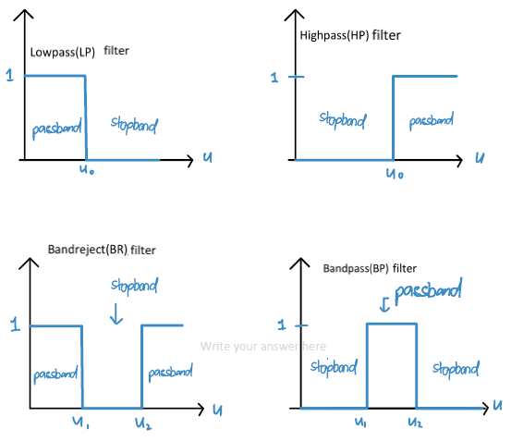

A highpass (HP) filter in the spatial domain is obtained by subtracting a low pass filter from a unit impulse with the same centre as the kernel.

A bandreject (BR) filter can be constructed from the sum of a lowpass filter and a highpass filter with different cut-off frequencies.

A bandpass (BP) filter can be constructed from subtracting a unit impulse from a bandreject filter with the same center as the kernel.

1. Compute contrast stretched image for the following input image **f(x,y)** whose intensity range is [0 to 255]. Round-off the pixel values to the nearest integer. **(2 marks)**

|  |  |  |
| --- | --- | --- |
| **7** | **230** | **230** |
| **5** | **17** | **17** |
| **8** | **6** | **6** |

*Input image f(x,y)*

|  |  |  |
| --- | --- | --- |
| **2** | **255** | **255** |
| **0** | **14** | **14** |
| **3** | **1** | **1** |

*Contrast stretched image*

1. Compute histogram equalization for a 64 x 64, 3-bit image having pixel intensity values from 0 to 7 and the following pixel counts. Use rounding-off to the nearest integer when mapping to the intensity values. Draw the histograms (with axis labels) of the input and output images. Fill the following table. **(3+2 = 5 marks)**

|  |  |  |  |  |  |  |  |  |
| --- | --- | --- | --- | --- | --- | --- | --- | --- |
| **Intensity value (rk)** | r0 | r1 | r2 | r3 | r4 | r5 | r6 | r7 |
| **No. of pixels (nk)** | 158 | 364 | 1200 | 886 | 300 | 256 | 92 | 840 |
| **Pr(rk)** | 0.04 | 0.09 | 0.30 | 0.22 | 0.07 | 0.06 | 0.02 | 0.20 |
| **sk** | 0 | 1 | 3 | 5 | 5 | 5 | 6 | 7 |
| **rk to sk mapping** | 0->0 | 1->1 | 2->3 | 3->5 | 4->5 | 5->5 | 6->6 | 7->7 |
| **No. of pixels in sk** | 158 | 364 | 0 | 1200 | 0 | 1442 | 92 | 840 |
| **Pr(sk)** | 0.04 | 0.09 | 0 | 0.30 | 0 | 0.35 | 0.02 | 0.20 |

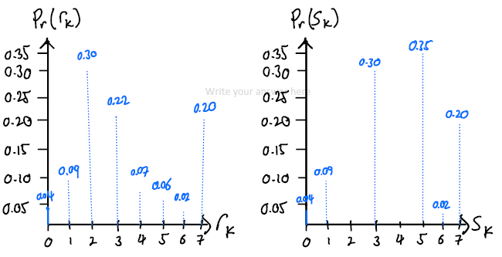

**Input image histogram**

**Output image histogram**

Write your answer here

1. Given below an input image f(x,y) whose intensity values are from 0 to 7: **(3+2 = 5 marks)**
   1. Compute the actual histogram for the given specified histogram. Use the histogram specified table for storing the intermediate results. Fill the following tables.
   2. Compute the histogram specified image.

*Input Image f(x,y) Histogram Specified Image*

|  |  |  |  |
| --- | --- | --- | --- |
| **4** | **1** | **2** | **3** |
| **2** | **2** | **4** | **0** |
| **6** | **1** | **5** | **7** |
| **1** | **0** | **1** | **3** |

|  |  |  |  |
| --- | --- | --- | --- |
| 6 | 4 | 4 | 5 |
| 4 | 4 | 6 | 3 |
| 7 | 4 | 6 | 7 |
| 4 | 3 | 4 | 5 |

*Histogram Specified Table*

|  |  |  |  |  |  |  |  |  |
| --- | --- | --- | --- | --- | --- | --- | --- | --- |
| **rk** | **0** | **1** | **2** | **3** | **4** | **5** | **6** | **7** |
| **Pz(zq) Specified Histogram** | **0** | **0** | **0** | **0.19** | **0.25** | **0.21** | **0.24** | **0.11** |
| **Pr(rk)** | 0.125 | 0.25 | 0.1875 | 0.125 | 0.125 | 0.0625 | 0.0625 | 0.0625 |
| **sk**  **(round-off)** | 1 | 3 | 4 | 5 | 6 | 6 | 7 | 7 |
| **rk**→**sk mapping** | 0->1 | 1->3 | 2->4 | 3->5 | 4->6 | 5->6 | 6->7 | 7->7 |
| **No. of pixels in sk** | 0 | 2 | 0 | 4 | 3 | 2 | 3 | 2 |
| **Pr(sk)** | 0 | 0.125 | 0 | 0.25 | 0.1875 | 0.125 | 0.1875 | 0.125 |
| **zq** | **0** | **1** | **2** | **3** | **4** | **5** | **6** | **7** |
| **G(zq)** | 0 | 0 | 0 | 1 | 3 | 5 | 6 | 7 |
| **sk**→**zq mapping** | 0->0 | 1->3 | 2->3 | 3->4 | 4->4 | 5->5 | 6->6 | 7->7 |
| **rk**→**sk**→ **zq mapping** | 0->1->3 | 1->3->4 | 2->4->4 | 3->5->5 | 4->6->6 | 5->6->6 | 6->7->7 | 7->7->7 |
| **Pz(zq) Actual Histogram** | 0 | 0 | 0 | 0.125 | 0.4375 | 0.125 | 0.1875 | 0.125 |

# --------------------------Rough Work Sheet-------------------------------

## (Scan it if it contains the rough work)